### PORTFOLIO PROJECT

Submitted by

**SADAIPANDI A**

**Reg. No : 1P22MC043**

In partial fulfilment of the requirement for the award of the Degree of

**Master of Computer**

**Applications Bharathiar**

**University Coimbatore**.

Under the Internal Supervision of

**Dr G Purusothaman M.sc., M.Phill., Ph.D.,**

Associate Professor

School of Computer Studies-MCA



**Master of Computer Applications,**

Rathnavel Subramaniam College of Arts and Science (Autonomous),

Sulur, Coimbatore – 641 402

Dec 2022

RATHNAVEL SUBRAMANIAM COLLEGE OF ARTS AND SCIENCE (AUTONOMOUS)

AFFLIATED TO BHARATHIAR UNIVERSITY

NAAC Re-accredited & ISO 9000:2008 Certified SULUR, COIMBATORE-641402.



Dec 2022

Register Number – 1P22MC043

Certified bonafide original record of work done by **SADAIPANDI A**

**Internal Supervisor HOD**

Submitted for the project Evaluation and Viva voice held on**………………….**

**Internal Examiner External Examiner**

PORTFOLIO PROJECT

**Chapter-1:**

Video Introduction

1.1 YouTube video 6

**Chapter-2:**

Website Bio Score 7

* 1. About me
  2. Contact Information

**Chapter-3:** 15

Pages & Navigations

* 1. Landing Page

3.2 Mobile View sample for one background image

3.3 Project Page

3.4 Navigation Bar

3.5 Skill Page

**Chapter-4:** 43

Style Score

4.1Styles

4.2Style links

**Chapter-5:**

Website include the following Information 44

* 1. Project link to the Github
  2. Project Description

**Chapter-6:**

Bootstrap 47

6.1 Uses of Bootstrap

**Chapter-7:**

Project README 48

* 1. Title description
  2. How to run the project
  3. Future improvement in the project

**Chapter-8:**  51

File Sturcture

8.1Github file structure

# Portfolio Project

PORTFOLIO PROJECT

## **Chapter 1:**

## You Tube Video

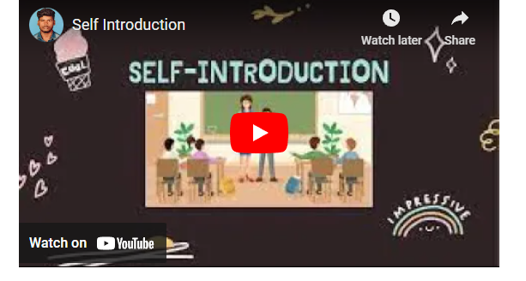

Source code:

CSS:

*video section*/

#video{flex-direction: column; max-width: 1400px;

margin: 0 auto;

width: 100%;

background-color: black;}

HTML:

<section id="video">

<center>

<iframe width="560" height="315" src="https://[www.youtube.com/embed/fPTDlSTF9lA"](http://www.youtube.com/embed/fPTDlSTF9lA) title="YouTube video player"

frameborder="0" allow="accelerometer; autoplay; clipboard-write; encrypted-media; gyroscope; picture-in-picture" allowfullscreen></iframe>

></center>

</section>

# Chapter2:

# Website Bio Score

2.1About me

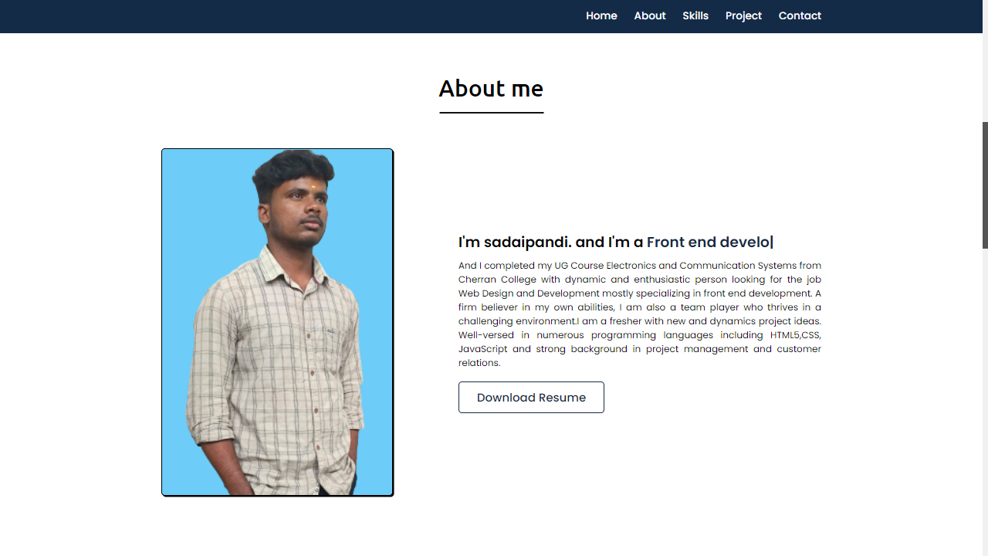

### Description:

In this page, there is an Image of mine, paragraph about me and also an option called DOWNLOAD RESUME. So, that if any user want to see the resume they can directly download from here.

HTML:

 <!-- about section start -->

    <section class="about" id="about">

        <div class="max-width">

            <h2 class="title">About me</h2>

            <div class="about-content">

                <div class="column left">

                    <img src="./images/11.png" alt="img">

                </div>

                <div class="column right">

                    <div class="text">I'm sadaipandi. and I'm a <span class="typing-2"></span></div>

                    <p> And I completed my UG Course Electronics and Communication Systems from Cherran College with  dynamic and enthusiastic person looking for the job Web Design and Development mostly specializing in front end development. A firm believer in my own abilities, I am also a

                        team player who thrives in a challenging environment.I am a fresher with new and dynamics project ideas. Well-versed in numerous programming languages including HTML5,CSS, JavaScript and strong background in project management and customer relations.  </p>

                    <a href="./CV_2022-11-28-015633.pdf" download="cv/sample.pdf">Download Resume</a>

                </div>

            </div>

        </div>

    </section>

CSS:

/* about section styling */

.about .about-content .left{

    width: 45%;

}

.about .about-content .left img{

    height: 600px;

    width: 400px;

    object-fit: cover;

    border-radius: 6px;

    border: 2px solid black;

    background-color: rgb(109, 204, 248);

    box-shadow: 2px 2px black;

}

.about .about-content .right{

    width: 55%;

}

.about .about-content .right .text{

    font-size: 25px;

    font-weight: 600;

    margin-bottom: 10px;

}

.about .about-content .right .text span{

    color: #142b47;

}

.about .about-content .right p{

    text-align: justify;

}

.about .about-content .right a{

     display: inline-block;

    /* background: crimson; */

    color: #142b47;

    font-size: 20px;

    font-weight: 500;

    padding: 10px 30px;

    margin-top: 20px;

    border-radius: 6px;

    border: 2px solid #142b47;

    transition: all 0.3s ease-in-out;

}

.about .about-content .right a:hover{

   color: white;

    background: #142b47;

}

2.2Page content

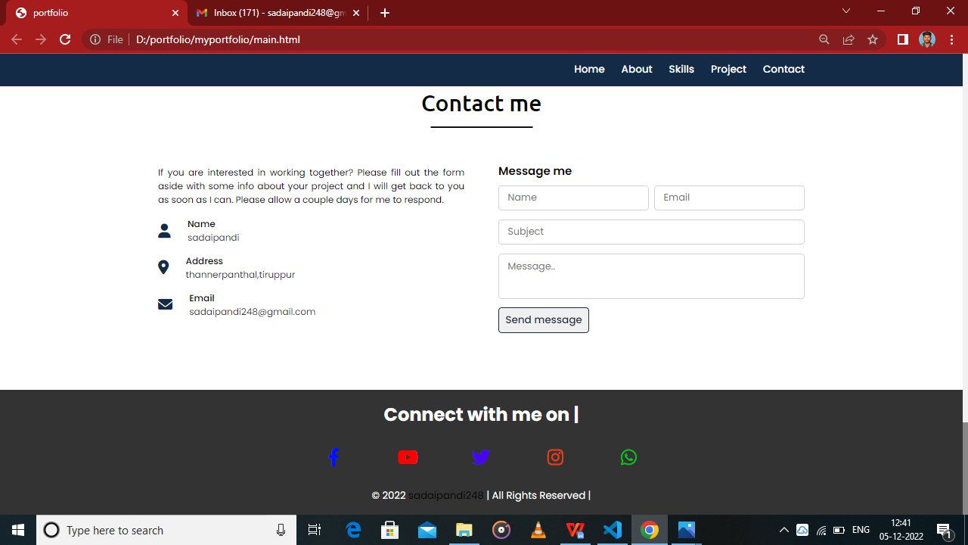

### Description:

The above displayed figure is a contact page in the website. If the user wants to contact me, they can fill the form with their valid details. Once the user filled and submitted the form the page will be displayed as figure . This will be possible only after filled the all fields in the form.

HTML:

  <!-- contact section start -->

    <section class="contact" id="contact">

        <div class="max-width">

            <h2 class="title">Contact me</h2>

            <div class="contact-content">

                <div class="column left">

                    <p>If you are interested in working together? Please fill out the form aside with some info about your project and I will get back to you as soon as I can. Please allow a couple days for me to respond.</p>

                    <div class="icons">

                        <div class="row">

                            <i class="fas fa-user"></i>

                            <div class="info">

                                <div class="head">Name</div>

                                <div class="sub-title">sadaipandi</div>

                            </div>

                        </div>

                        <div class="row">

                            <i class="fas fa-map-marker-alt"></i>

                            <div class="info">

                                <div class="head">Address</div>

                                <div class="sub-title">thannerpanthal,tiruppur</div>

                            </div>

                        </div>

                        <div class="row">

                            <i class="fas fa-envelope"></i>

                            <div class="info">

                                <div class="head">Email</div>

                                <div class="sub-title">sadaipandi248@gmail.com</div>

                            </div>

                        </div>

                    </div>

                </div>

                <div class="column right">

                    <div class="text">Message me</div>

                    <form action="#">

                        <div class="fields">

                            <div class="field name">

                                <input type="text" placeholder="Name" required>

                            </div>

                            <div class="field email">

                                <input type="email" placeholder="Email" required>

                            </div>

                        </div>

                        <div class="field">

                            <input type="text" placeholder="Subject" required>

                        </div>

                        <div class="field textarea">

                            <textarea cols="30" rows="10" placeholder="Message.." required></textarea>

                        </div>

                        <div class="button-area">

                            <button type="submit">Send message</button>

                        </div>

                    </form>

                </div>

            </div>

        </div>

    </section>

CSS:

/* contact section styling */

input,textarea

{

    caret-color: red;

}

.contact .contact-content .column{

    width: calc(50% - 30px);

}

.contact .contact-content .text{

    font-size: 20px;

    font-weight: 600;

    margin-bottom: 10px;

}

.contact .contact-content .left p{

    text-align: justify;

}

.contact .contact-content .left .icons{

    margin: 10px 0;

}

.contact .contact-content .row{

    display: flex;

    height: 65px;

    align-items: center;

}

.contact .contact-content .row .info{

    margin-left: 30px;

}

.contact .contact-content .row i{

    font-size: 25px;

    color: #142b47;

}

.contact .contact-content .info .head{

    font-weight: 500;

}

.contact .contact-content .info .sub-title{

    color: #333;

}

.contact .right form .fields{

    display: flex;

}

.contact .right form .field,

.contact .right form .fields .field{

    height: 45px;

    width: 100%;

    margin-bottom: 15px;

}

.contact .right form .textarea{

    height: 80px;

    width: 100%;

}

.contact .right form .name{

    margin-right: 10px;

}

.contact .right form .field input,

.contact .right form .textarea textarea{

    height: 100%;

    width: 100%;

    border: 1px solid lightgrey;

    border-radius: 6px;

    outline: none;

    padding: 0 15px;

    font-size: 17px;

    font-family: 'Poppins', sans-serif;

    transition: all 0.3s ease;

}

.contact .right form .field input:focus,

.contact .right form .textarea textarea:focus{

    border-color: #b3b3b3;

}

.contact .right form .textarea textarea{

  padding-top: 10px;

  resize: none;

}

.contact .right form .button-area{

  display: flex;

  align-items: center;

}

.right form .button-area button{

  color: #142b47;

  display: block;

  width: 160px!important;

  height: 45px;

  outline: none;

  font-size: 18px;

  font-weight: 500;

  border-radius: 6px;

  cursor: pointer;

  flex-wrap: nowrap;

  border: 2px solid #142b47;

  transition: all 0.3s ease-in-out;

}

.right form .button-area button:hover{

  color: white;

  background: #142b47;

}

Chapter3:

### Pages&Navigation

3.1Landing Page

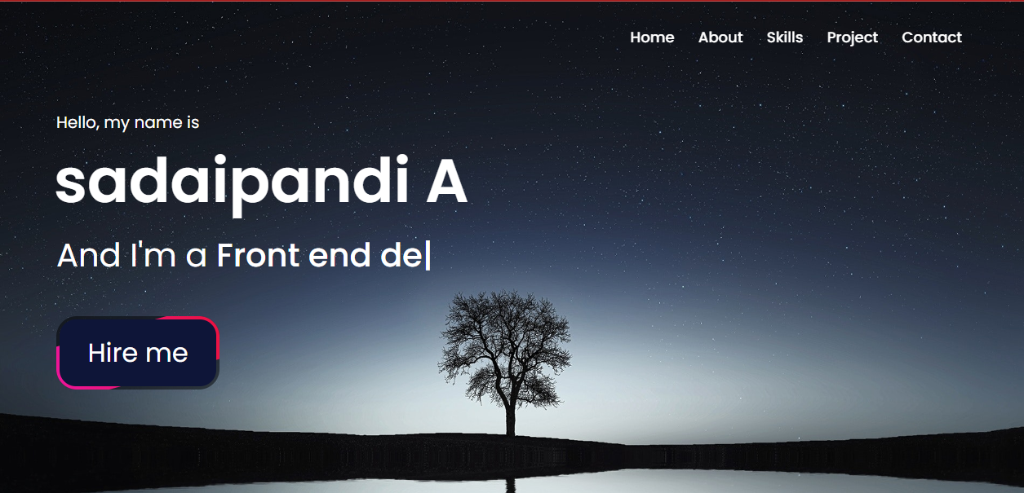

### **Description:**

Actually the above images are landing page, because I have created the page as an animation. So the background images will be move repeatedly at a time interval of specific second. And also I have added a favicon to the website at the title.

### HTML:

 <!-- Nav bar  -->

 <div id="preloader"></div>

    <nav class="navbar">

        <div class="max-width">

            <div class="logo"><a href="#"><span></span></a></div>

            <ul class="menu">

                <li><a href="#home" class="menu-btn">Home</a></li>

                <li><a href="#about" class="menu-btn">About</a></li>

                <li><a href="#skills" class="menu-btn">Skills</a></li>

                <li><a href="#teams" class="menu-btn">Project</a></li>

                <li><a href="#contact" class="menu-btn">Contact</a></li>

            </ul>

            <div class="menu-btn">

                <i class="fas fa-bars"></i>

            </div>

        </div>

    </nav>

    <!-- home section start -->

    <section class="home" id="home">

        <div class="max-width">

            <div class="home-content">

                <div class="text-1">Hello, my name is</div>

                <div class="text-2">sadaipandi A</div>

                <div class="text-3">And I'm a <span class="typing"></span></div>

                <div class="classbox">

                <a href="./CV_2022-11-28-015633.pdf">Hire me</a>

            </div>

            </div>

        </div>

    </section>

### CSS:

/*  import google fonts */

@import url('https://fonts.googleapis.com/css2?family=Poppins:wght@400;500;600;700&family=Ubuntu:wght@400;500;700&display=swap');

*{

    margin: 0;

    padding: 0;

    box-sizing: border-box;

    text-decoration: none;

    font-family: 'Poppins', sans-serif;

/*     font-family: consolas; */

}

html{

    scroll-behavior: smooth;

}

/* custom scroll bar */

::-webkit-scrollbar {

    width: 10px;

}

::-webkit-scrollbar-track {

    background: #f1f1f1;

}

::-webkit-scrollbar-thumb {

    background: #888;

}

::-webkit-scrollbar-thumb:hover {

    background: #555;

}

/* all similar content styling codes */

section{

    padding: 100px 0;

}

.max-width{

    max-width: 1300px;

    padding: 0 80px;

    margin: auto;

}

.about, .services, .skills, .teams, .contact, footer{

    font-family: 'Poppins', sans-serif;

}

.about .about-content,

.services .serv-content,

.skills .skills-content,

.contact .contact-content{

    display: flex;

    flex-wrap: wrap;

    align-items: center;

    justify-content: space-between;

}

section .title{

    position: relative;

    text-align: center;

    font-size: 40px;

    font-weight: 500;

    margin-bottom: 60px;

    padding-bottom: 20px;

    font-family: 'Ubuntu', sans-serif;

}

section .title::before{

    content: "";

    position: absolute;

    bottom: 0px;

    left: 50%;

    width: 180px;

    height: 3px;

    background: #111;

    transform: translateX(-50%);

}

section .title::after{

    position: absolute;

    bottom: -8px;

    left: 50%;

    font-size: 20px;

    color: #142b47;

    padding: 0 5px;

    background: #fff;

    transform: translateX(-50%);

}

/* navbar styling */

.navbar{

    position: fixed;

    width: 100%;

    z-index: 999;

    padding: 30px 0;

    font-family: 'Ubuntu', sans-serif;

    transition: all 0.3s ease;

}

.navbar.sticky{

    padding: 15px 0;

    background: #142b47;

}

.navbar .max-width{

    display: flex;

    align-items: center;

    justify-content: space-between;

}

.navbar .logo a{

    color: #fff;

    font-size: 35px;

    font-weight: 600;

    cursor: pointer;

}

.navbar .logo a span{

    color: #142b47;

    transition: all 0.3s ease;

}

.navbar.sticky .logo a span{

    color: #fff;

}

.navbar .menu li{

    list-style: none;

    display: inline-block;

}

.navbar .menu li a{

    display: block;

    color: #fff;

    font-size: 18px;

    font-weight: 500;

    margin-left: 25px;

    transition: color 0.3s ease;

}

.navbar .menu li a:hover{

    color: #142b47;

    cursor: pointer;

}

.navbar.sticky .menu li a:hover{

    color: #fff;

    cursor: pointer;

}

/* menu btn styling */

.menu-btn{

    color: #fff;

    font-size: 23px;

    cursor: pointer;

    display: none;

}

.scroll-up-btn{

    position: fixed;

    height: 45px;

    width: 42px;

    background: #142b47;

    right: 30px;

    bottom: 10px;

    text-align: center;

    line-height: 45px;

    color: #fff;

    z-index: 9999;

    font-size: 30px;

    border-radius: 6px;

    border-bottom-width: 2px;

    cursor: pointer;

    opacity: 0;

    pointer-events: none;

    transition: all 0.3s ease;

}

.scroll-up-btn.show{

    bottom: 30px;

    opacity: 1;

    pointer-events: auto;

}

.scroll-up-btn:hover{

    filter: brightness(90%);

}

/* home section styling */

.home{

    display: flex;

    background: url(./images/pexels-pixabay-35796\ \(1\).jpg);

    /* background: url("https://images.pexels.com/photos/4360449/pexels-photo-4360449.jpeg?auto=compress&cs=tinysrgb&w=1260&h=750&dpr=2") no-repeat center; */

    height: 100vh;

    color: #fff;

    min-height: 500px;

    background-size: cover;

    background-attachment: fixed;

    font-family: 'Ubuntu', sans-serif;

}

.home .max-width{

  width: 100%;

  display: flex;

}

.home .max-width .row{

  margin-right: 0;

}

.home .home-content .text-1{

    font-size: 20px;

}

.home .home-content .text-2{

    font-size: 75px;

    font-weight: 600;

    margin-left: -3px;

}

.home .home-content .text-3{

    font-size: 40px;

    margin: 5px 0;

}

.home .home-content .text-3 span{

    color: #fff;

    font-weight: 500;

}

.classbox

{

    position: relative;

    width: 200px;

    height: 90px;

    display: flex;

    justify-content: center;

    align-items: center;

    background: rgba(0, 0, 0, 0.5);

    overflow: hidden;

    border-radius: 25px;

    margin-top: 45px;

    cursor: pointer;

}

.classbox::before

{

    content: '';

    position: absolute;

    width: 68px;

    height: 500%;

    border-radius: 0;

    background: linear-gradient(#ee17ca,#eb1010);

    animation: animate-rotate 4s linear infinite;

}

.classbox::after

{

    content: '';

    position: absolute;

    inset: 4px;

    background: #0e1538;

    /* background: crimson; */

    border-radius: 20px;

}

@keyframes animate-rotate

{

    0%

    {

        transform: rotate(0deg);

    }

    100%

    {

        transform: rotate(360deg);

    }

}

.classbox a

{

    text-decoration: none;

    color: #fff;

    font-size: 2em;

    z-index: 10;

    cursor: pointer;

}

3.2Mobile View sample for one background image

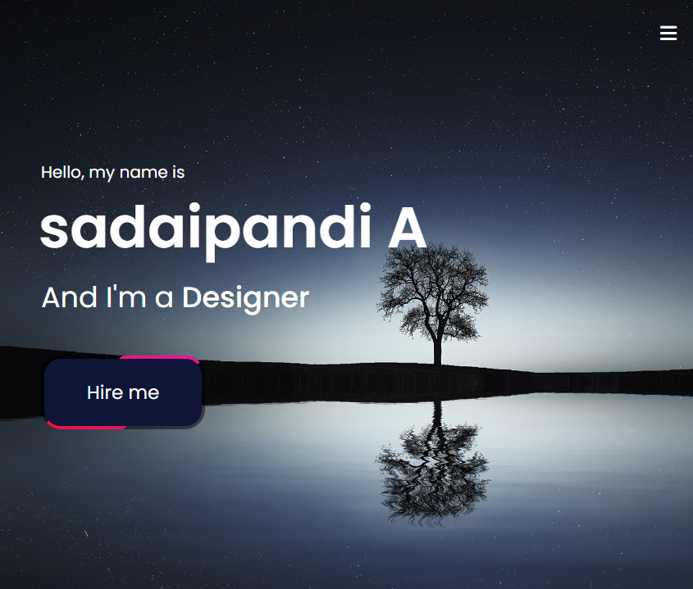

### HTML:

<html>

<head>

<title>portfolio</title>

<link rel="stylesheet" href="https://cdnjs.cloudflare.com/ajax/libs/font-awesome/5.15.3/css/all.min.css"/>

    <script src="https://code.jquery.com/jquery-3.5.1.min.js"></script>

    <script src="https://cdnjs.cloudflare.com/ajax/libs/typed.js/2.0.11/typed.min.js"></script>

    <script src="https://cdnjs.cloudflare.com/ajax/libs/waypoints/4.0.1/jquery.waypoints.min.js"></script>

    <script src="https://cdnjs.cloudflare.com/ajax/libs/OwlCarousel2/2.3.4/owl.carousel.min.js"></script>

    <link rel="stylesheet" href="https://cdnjs.cloudflare.com/ajax/libs/OwlCarousel2/2.3.4/assets/owl.carousel.min.css"/>

    <link rel="stylesheet" href="https://cdnjs.cloudflare.com/ajax/libs/font-awesome/6.0.0/css/all.min.css" integrity="sha512-9usAa10IRO0HhonpyAIVpjrylPvoDwiPUiKdWk5t3PyolY1cOd4DSE0Ga+ri4AuTroPR5aQvXU9xC6qOPnzFeg==" crossorigin="anonymous" referrerpolicy="no-referrer">

    <link rel="stylesheet" href="./main.css">

    <script src="./main.js"></script>

</head>

<body>

    <!-- Nav bar  -->

 <div id="preloader"></div>

    <nav class="navbar">

        <div class="max-width">

            <div class="logo"><a href="#"><span></span></a></div>

            <ul class="menu">

                <li><a href="#home" class="menu-btn">Home</a></li>

                <li><a href="#about" class="menu-btn">About</a></li>

                <li><a href="#skills" class="menu-btn">Skills</a></li>

                <li><a href="#teams" class="menu-btn">Project</a></li>

                <li><a href="#contact" class="menu-btn">Contact</a></li>

            </ul>

            <div class="menu-btn">

                <i class="fas fa-bars"></i>

            </div>

        </div>

    </nav>

    <!-- home section start -->

    <section class="home" id="home">

        <div class="max-width">

            <div class="home-content">

                <div class="text-1">Hello, my name is</div>

                <div class="text-2">sadaipandi A</div>

                <div class="text-3">And I'm a <span class="typing"></span></div>

                <div class="classbox">

                <a href="./CV_2022-11-28-015633.pdf">Hire me</a>

            </div>

            </div>

        </div>

    </section>

**CSS:**

/*  import google fonts */

@import url('https://fonts.googleapis.com/css2?family=Poppins:wght@400;500;600;700&family=Ubuntu:wght@400;500;700&display=swap');

*{

    margin: 0;

    padding: 0;

    box-sizing: border-box;

    text-decoration: none;

    font-family: 'Poppins', sans-serif;

/*     font-family: consolas; */

}

html{

    scroll-behavior: smooth;

}

/* custom scroll bar */

::-webkit-scrollbar {

    width: 10px;

}

::-webkit-scrollbar-track {

    background: #f1f1f1;

}

::-webkit-scrollbar-thumb {

    background: #888;

}

::-webkit-scrollbar-thumb:hover {

    background: #555;

}

/* all similar content styling codes */

section{

    padding: 100px 0;

}

.max-width{

    max-width: 1300px;

    padding: 0 80px;

    margin: auto;

}

.about, .services, .skills, .teams, .contact, footer{

    font-family: 'Poppins', sans-serif;

}

.about .about-content,

.services .serv-content,

.skills .skills-content,

.contact .contact-content{

    display: flex;

    flex-wrap: wrap;

    align-items: center;

    justify-content: space-between;

}

section .title{

    position: relative;

    text-align: center;

    font-size: 40px;

    font-weight: 500;

    margin-bottom: 60px;

    padding-bottom: 20px;

    font-family: 'Ubuntu', sans-serif;

}

section .title::before{

    content: "";

    position: absolute;

    bottom: 0px;

    left: 50%;

    width: 180px;

    height: 3px;

    background: #111;

    transform: translateX(-50%);

}

section .title::after{

    position: absolute;

    bottom: -8px;

    left: 50%;

    font-size: 20px;

    color: #142b47;

    padding: 0 5px;

    background: #fff;

    transform: translateX(-50%);

}

/* navbar styling */

.navbar{

    position: fixed;

    width: 100%;

    z-index: 999;

    padding: 30px 0;

    font-family: 'Ubuntu', sans-serif;

    transition: all 0.3s ease;

}

.navbar.sticky{

    padding: 15px 0;

    background: #142b47;

}

.navbar .max-width{

    display: flex;

    align-items: center;

    justify-content: space-between;

}

.navbar .logo a{

    color: #fff;

    font-size: 35px;

    font-weight: 600;

    cursor: pointer;

}

.navbar .logo a span{

    color: #142b47;

    transition: all 0.3s ease;

}

.navbar.sticky .logo a span{

    color: #fff;

}

.navbar .menu li{

    list-style: none;

    display: inline-block;

}

.navbar .menu li a{

    display: block;

    color: #fff;

    font-size: 18px;

    font-weight: 500;

    margin-left: 25px;

    transition: color 0.3s ease;

}

.navbar .menu li a:hover{

    color: #142b47;

    cursor: pointer;

}

.navbar.sticky .menu li a:hover{

    color: #fff;

    cursor: pointer;

}

/* menu btn styling */

.menu-btn{

    color: #fff;

    font-size: 23px;

    cursor: pointer;

    display: none;

}

.scroll-up-btn{

    position: fixed;

    height: 45px;

    width: 42px;

    background: #142b47;

    right: 30px;

    bottom: 10px;

    text-align: center;

    line-height: 45px;

    color: #fff;

    z-index: 9999;

    font-size: 30px;

    border-radius: 6px;

    border-bottom-width: 2px;

    cursor: pointer;

    opacity: 0;

    pointer-events: none;

    transition: all 0.3s ease;

}

.scroll-up-btn.show{

    bottom: 30px;

    opacity: 1;

    pointer-events: auto;

}

.scroll-up-btn:hover{

    filter: brightness(90%);

}

/* home section styling */

.home{

    display: flex;

    background: url(./images/pexels-pixabay-35796\ \(1\).jpg);

    /* background: url("https://images.pexels.com/photos/4360449/pexels-photo-4360449.jpeg?auto=compress&cs=tinysrgb&w=1260&h=750&dpr=2") no-repeat center; */

    height: 100vh;

    color: #fff;

    min-height: 500px;

    background-size: cover;

    background-attachment: fixed;

    font-family: 'Ubuntu', sans-serif;

}

.home .max-width{

  width: 100%;

  display: flex;

}

.home .max-width .row{

  margin-right: 0;

}

.home .home-content .text-1{

    font-size: 20px;

}

.home .home-content .text-2{

    font-size: 75px;

    font-weight: 600;

    margin-left: -3px;

}

.home .home-content .text-3{

    font-size: 40px;

    margin: 5px 0;

}

.home .home-content .text-3 span{

    color: #fff;

    font-weight: 500;

}

.classbox

{

    position: relative;

    width: 200px;

    height: 90px;

    display: flex;

    justify-content: center;

    align-items: center;

    background: rgba(0, 0, 0, 0.5);

    overflow: hidden;

    border-radius: 25px;

    margin-top: 45px;

    cursor: pointer;

}

.classbox::before

{

    content: '';

    position: absolute;

    width: 68px;

    height: 500%;

    border-radius: 0;

    background: linear-gradient(#ee17ca,#eb1010);

    animation: animate-rotate 4s linear infinite;

}

.classbox::after

{

    content: '';

    position: absolute;

    inset: 4px;

    background: #0e1538;

    /* background: crimson; */

    border-radius: 20px;

}

@keyframes animate-rotate

{

    0%

    {

        transform: rotate(0deg);

    }

    100%

    {

        transform: rotate(360deg);

    }

}

.classbox a

{

    text-decoration: none;

    color: #fff;

    font-size: 2em;

    z-index: 10;

    cursor: pointer;

}

**JS:**

$(document).ready(function(){

    $(window).scroll(function(){

        // sticky navbar on scroll script

        if(this.scrollY > 20){

            $('.navbar').addClass("sticky");

        }else{

            $('.navbar').removeClass("sticky");

        }

        // scroll-up button show/hide script

        if(this.scrollY > 500){

            $('.scroll-up-btn').addClass("show");

        }else{

            $('.scroll-up-btn').removeClass("show");

        }

    });

    // slide-up script

    $('.scroll-up-btn').click(function(){

        $('html').animate({scrollTop: 0});

        // removing smooth scroll on slide-up button click

        $('html').css("scrollBehavior", "auto");

    });

    $('.navbar .menu li a').click(function(){

        // applying again smooth scroll on menu items click

        $('html').css("scrollBehavior", "smooth");

    });

    // toggle menu/navbar script

    $('.menu-btn').click(function(){

        $('.navbar .menu').toggleClass("active");

        $('.menu-btn i').toggleClass("active");

    });

    // typing text animation script

    var typed = new Typed(".typing", {

        strings: ["Front end developer","Fresher","Traveller", "Blogger", "Designer"],

        typeSpeed: 100,

        backSpeed: 60,

        loop: true

    });

    var typed = new Typed(".typing-3", {

        strings: ["Connect with me on :)"],

        typeSpeed: 100,

        backSpeed: 60,

        loop: true

    });

3.3Project Page:

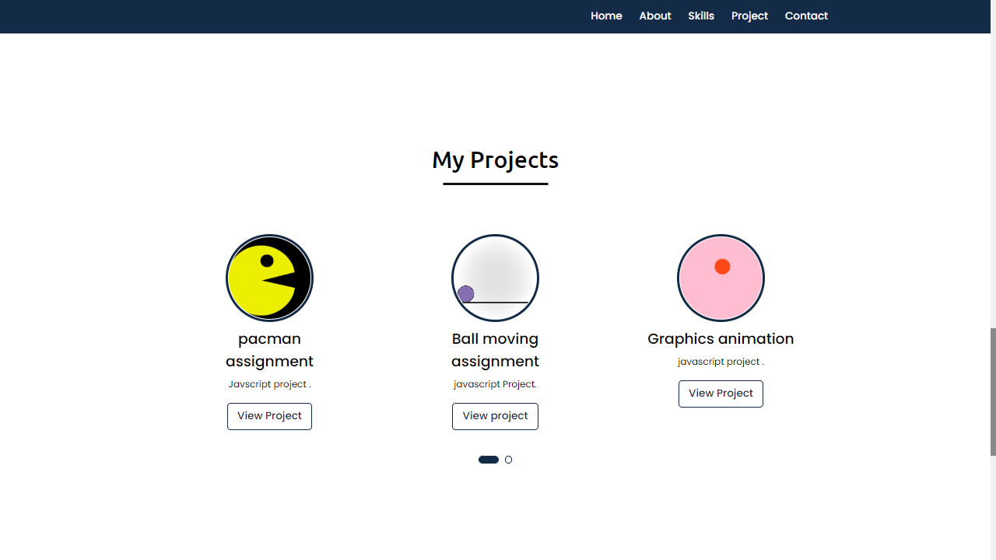

**HTML:**

 <!-- project section start -->

        <section class="teams" id="teams">

            <div class="max-width">

                <h2 class="title">My Projects</h2>

                <div class="carousel owl-carousel">

                    <div class="card">

                        <div class="box">

                            <img src="./images/pacman.gif" alt="img">

                            <div class="text">pacman <br> assignment</div>

                            <p>Javscript project . </p>

                            <a href="https://github.com/RathnavelSubramaniam/week-4-introduction-to-javascript-Sadaipandi248" class="project" target="_blank">View Project</a>

                        </div>

                    </div>

                    <div class="card">

                        <div class="box">

                            <img src="./images/Principles-of-Animation_Anticipation_RolliingBall.gif" alt="img">

                            <div class="text">Ball moving <br> assignment</div>

                            <p>javascript Project.</p>

                            <a href="https://github.com/RathnavelSubramaniam/week-2-javascript-Sadaipandi248.git" class="project" target="_blank">View project</a>

                        </div>

                    </div>

                    <div class="card">

                        <div class="box">

                            <img src="./images/ball.gif" alt="img">

                            <div class="text">Graphics animation</div>

                            <p>javascript project .</p>

                            <a href="#" class="project" target="_blank">View Project</a>

                        </div>

                    </div>

                    <div class="card">

                        <!-- <div class="box">

                            <img src="https://images.pexels.com/photos/1779487/pexels-photo-1779487.jpeg?auto=compress&cs=tinysrgb&w=1260&h=750&dpr=2" alt="img">

                            <div class="text">NRD Computers</div>

                            <p>NRD Computer is an eCommerce project.</p>

                            <a href="https://nrd.com.np/" class="project" target="_blank">View Project</a>

                        </div> -->

                    </div>

                </div>

            </div>

        </section>

**CSS:**

/* projects section styling */

.teams .carousel .card{

    background:white;

    border-radius: 6px;

    padding: 25px 35px;

    text-align: center;

    overflow: hidden;

    transition: all 0.3s ease;

}

 .teams .carousel .card .box{

    display: flex;

    flex-direction: column;

    align-items: center;

    justify-content: center;

    transition: all 0.3s ease;

}

.teams .carousel .card .text{

    font-size: 25px;

    font-weight: 500;

    margin: 10px 0 7px 0;

}

.teams .carousel .card img{

    height: 150px;

    width: 150px;

    object-fit: cover;

    border-radius: 50%;

    border: 5px solid #142b47;

    transition: all 0.3s ease;

}

.teams .carousel .card:hover img{

    border-color: #fff;

}

.owl-dots{

    text-align: center;

    margin-top: 20px;

}

.owl-dot{

    height: 13px;

    width: 13px;

    margin: 0 5px;

    outline: none!important;

    border-radius: 50%;

    border: 2px solid #142b47!important;

    transition: all 0.3s ease;

}

.owl-dot.active{

    width: 35px;

    border-radius: 14px;

}

.owl-dot.active,

.owl-dot:hover{

    background: #142b47!important;

}

.teams .carousel .card .box .project

{

    display: inline-block;

    color: #142b47;

    font-size: 18px;

    font-weight: 500;

    padding: 8px 16px;

    margin-top: 20px;

    border-radius: 6px;

    border: 2px solid #142b47;

    transition: 0.3s ease-in-out;

}

.teams .carousel .card .box .project:hover{

    color: white;

    background: #142b47;

}

**JS:**

 // owl carousel script

 $('.carousel').owlCarousel({

    margin: 20,

    loop: true,

    autoplay: true,

    autoplayTimeOut: 2000  ,

    autoplayHoverPause: true,

    responsive: {

        0:{

            items: 1,

            nav: false

        },

        600:{

            items: 2,

            nav: false

        },

        1000:{

            items: 3,

            nav: false

        }

    }

});

3.4Navigation bar:



### Features:

There are many styles are added. Whenever the user move lists to the navigation bar it will change the color to goldenrod. And also the navigation bar will be stable in the same position, even we switch to any other pages.

**HTML:**

<!-- Nav bar  -->

 <div id="preloader"></div>

    <nav class="navbar">

        <div class="max-width">

            <div class="logo"><a href="#"><span></span></a></div>

            <ul class="menu">

                <li><a href="#home" class="menu-btn">Home</a></li>

                <li><a href="#about" class="menu-btn">About</a></li>

                <li><a href="#skills" class="menu-btn">Skills</a></li>

                <li><a href="#teams" class="menu-btn">Project</a></li>

                <li><a href="#contact" class="menu-btn">Contact</a></li>

            </ul>

            <div class="menu-btn">

                <i class="fas fa-bars"></i>

            </div>

        </div>

    </nav>

**CSS:**

/* navbar styling */

.navbar{

    position: fixed;

    width: 100%;

    z-index: 999;

    padding: 30px 0;

    font-family: 'Ubuntu', sans-serif;

    transition: all 0.3s ease;

}

.navbar.sticky{

    padding: 15px 0;

    background: #142b47;

}

.navbar .max-width{

    display: flex;

    align-items: center;

    justify-content: space-between;

}

.navbar .logo a{

    color: #fff;

    font-size: 35px;

    font-weight: 600;

    cursor: pointer;

}

.navbar .logo a span{

    color: #142b47;

    transition: all 0.3s ease;

}

.navbar.sticky .logo a span{

    color: #fff;

}

.navbar .menu li{

    list-style: none;

    display: inline-block;

}

.navbar .menu li a{

    display: block;

    color: #fff;

    font-size: 18px;

    font-weight: 500;

    margin-left: 25px;

    transition: color 0.3s ease;

}

.navbar .menu li a:hover{

    color: #142b47;

    cursor: pointer;

}

.navbar.sticky .menu li a:hover{

    color: #fff;

    cursor: pointer;

}

**JS:**

$(document).ready(function(){

    $(window).scroll(function(){

        // sticky navbar on scroll script

        if(this.scrollY > 20){

            $('.navbar').addClass("sticky");

        }else{

            $('.navbar').removeClass("sticky");

        }

        // scroll-up button show/hide script

        if(this.scrollY > 500){

            $('.scroll-up-btn').addClass("show");

        }else{

            $('.scroll-up-btn').removeClass("show");

        }

    });

    // slide-up script

    $('.scroll-up-btn').click(function(){

        $('html').animate({scrollTop: 0});

        // removing smooth scroll on slide-up button click

        $('html').css("scrollBehavior", "auto");

    });

    $('.navbar .menu li a').click(function(){

        // applying again smooth scroll on menu items click

        $('html').css("scrollBehavior", "smooth");

    });

    // toggle menu/navbar script

    $('.menu-btn').click(function(){

        $('.navbar .menu').toggleClass("active");

        $('.menu-btn i').toggleClass("active");

    });

3.5Skill page:

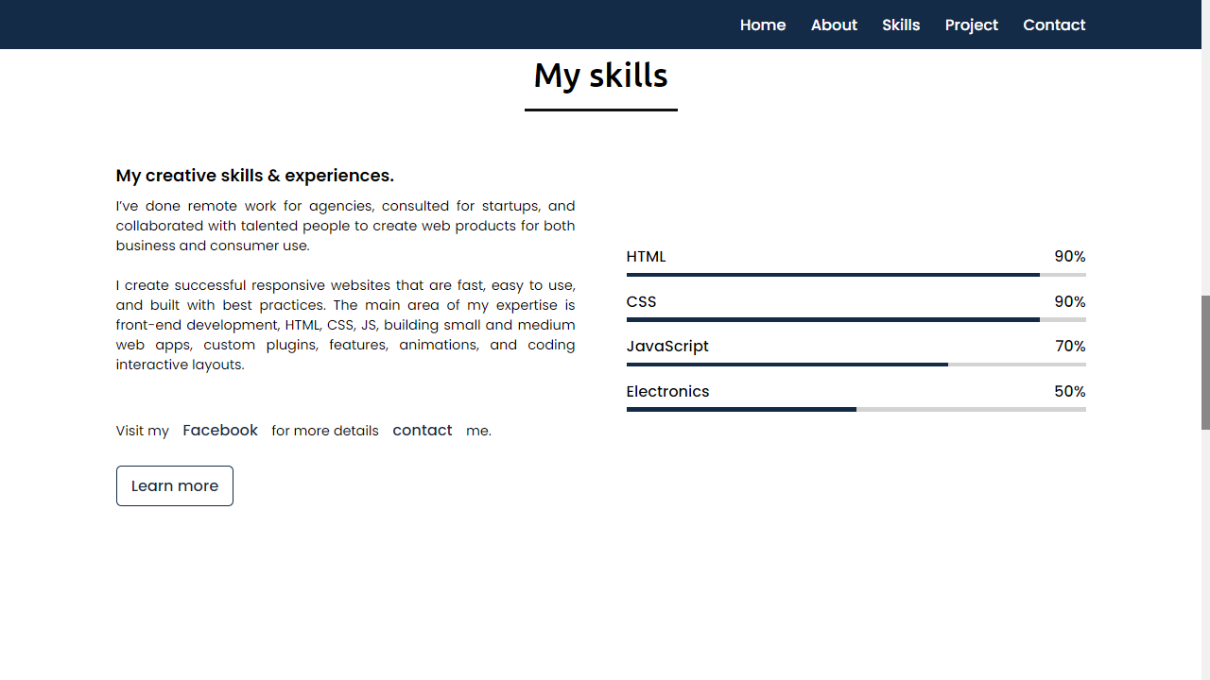

### HTML:

<!-- skills section start -->

    <section class="skills" id="skills">

        <div class="max-width">

            <h2 class="title">My skills</h2>

            <div class="skills-content">

                <div class="column left">

                    <div class="text">My creative skills & experiences.</div>

                    <p> I’ve done remote work for agencies, consulted for startups, and collaborated with talented people to create web products for both business and consumer use.

                        <br><br>

                        I create successful responsive websites that are fast, easy to use, and built with best practices. The main area of my expertise is front-end development, HTML, CSS, JS, building small and medium web apps, custom plugins, features, animations, and coding interactive layouts.

                        <br>

                        <br>

                        Visit my<a href="https://www.facebook.com/profile.php?id=100030289760771" target="-blank" id="link">Facebook</a>for more details<a href="#contact" id="link">contact</a>me.

                    </p>

                    <a href="#contact">Learn more</a>

                </div>

                <div class="column right">

                    <div class="bars">

                        <div class="info">

                            <span>HTML</span>

                            <span>90%</span>

                        </div>

                        <div class="line html"></div>

                    </div>

                    <div class="bars">

                        <div class="info">

                            <span>CSS</span>

                            <span>90%</span>

                        </div>

                        <div class="line css"></div>

                    </div>

                    <div class="bars">

                        <div class="info">

                            <span>JavaScript</span>

                            <span>70%</span>

                        </div>

                         <div class="line js"></div>

                    </div>

                <div class="bars">

                        <div class="info">

                            <span>Electronics</span>

                            <span>50%</span>

                        </div>

                        <div class="line php"></div>

                    </div>

                </div>

            </div>

        </div>

    </section>

**CSS:**

/* skills section styling */

.skills .skills-content .column{

    width: calc(50% - 30px);

}

.skills .skills-content .left .text{

    font-size: 20px;

    font-weight: 600;

    margin-bottom: 10px;

}

.skills .skills-content .left p{

    text-align: justify;

}

.skills .skills-content .left a{

    display: inline-block;

    /* background: crimson; */

    color: #142b47;

    font-size: 18px;

    font-weight: 500;

    padding: 8px 16px;

    margin-top: 20px;

    border-radius: 6px;

    border: 2px solid #142b47;

    transition: 0.3s ease-in-out;

}

.skills .skills-content .left a:hover{

    color: white;

    background: #142b47;

}

.skills .skills-content .left p #link

{

    border: none;

    text-decoration: none;

    color: #142b47;

}

.skills .skills-content .left p #link:hover

{

    color: rgb(223, 26, 69);

    /* text-transform: uppercase; */

    text-decoration: underline;

    background: none;

}

.skills .skills-content .right .bars{

    margin-bottom: 15px;

}

.skills .skills-content .right .info{

    display: flex;

    margin-bottom: 5px;

    align-items: center;

    justify-content: space-between;

}

.skills .skills-content .right span{

    font-weight: 500;

    font-size: 18px;

}

.skills .skills-content .right .line{

    height: 5px;

    width: 100%;

    background: lightgrey;

    position: relative;

}

.skills .skills-content .right .line::before{

    content: "";

    position: absolute;

    height: 100%;

    left: 0;

    top: 0;

    background: #142b47;

}

.skills-content .right .html::before{

    width: 90%;

}

.skills-content .right .css::before{

    width: 90%;

}

.skills-content .right .js::before{

    width: 70%;

}

.skills-content .right .php::before{

    width: 50%;

}

**Chapter4:**

4.1Font link

/*  import google fonts */

@import url('https://fonts.googleapis.com/css2?family=Poppins:wght@400;500;600;700&family=Ubuntu:wght@400;500;700&display=swap');

4.2Style link

<link rel="stylesheet" href="https://cdnjs.cloudflare.com/ajax/libs/font-awesome/5.15.3/css/all.min.css"/>

    <script src="https://code.jquery.com/jquery-3.5.1.min.js"></script>

    <script src="https://cdnjs.cloudflare.com/ajax/libs/typed.js/2.0.11/typed.min.js"></script>

    <script src="https://cdnjs.cloudflare.com/ajax/libs/waypoints/4.0.1/jquery.waypoints.min.js"></script>

    <script src="https://cdnjs.cloudflare.com/ajax/libs/OwlCarousel2/2.3.4/owl.carousel.min.js"></script>

    <link rel="stylesheet" href="https://cdnjs.cloudflare.com/ajax/libs/OwlCarousel2/2.3.4/assets/owl.carousel.min.css"/>

    <link rel="stylesheet" href="https://cdnjs.cloudflare.com/ajax/libs/font-awesome/6.0.0/css/all.min.css" integrity="sha512-9usAa10IRO0HhonpyAIVpjrylPvoDwiPUiKdWk5t3PyolY1cOd4DSE0Ga+ri4AuTroPR5aQvXU9xC6qOPnzFeg==" crossorigin="anonymous" referrerpolicy="no-referrer">

    <link rel="stylesheet" href="./main.css">

##### Chapter5:

##### Website include the following information

* 1. project links to *Github:*

### * Project-1

**Title: *SIMULATION BALL MOVEMENT***

**Link: https://github.com/Sadaipandi248/Ball-movement.git**

* + - **Project Description:**

This project has a simple green color ball, Which will move from top to bottom and bottom to top, like bouncing from between the x and y axis. It will repeat this process whenever we load the page. The ball is created by HTML, CSS. And making the ball to do some event by JAVASCRIPT.

### * Project-2

**Title: *GRAPHIC ANIMATION OF THE RANDOM WALK EXERCISE***

**Link:https://github.com/Sadaipandi248/Graphics-animation-of-random-walk.git**

* + - **Project Description:**

This was a graphic animation of the random ball using plain JavaScript. Drawing in HTML Canvas, also plain CSS is used. The balls will bounce randomly within the box.

### * Project-3

**Title: *PAC-MAN MOVEMENT***

**Link: https://github.com/Sadaipandi248/Pacman-Project.git**

* + - **Project Description:**

In Simulation scheduler a Pac-man in made to move is fixed direction and with a fixed velocity. It will move from the one place of the browser to the end of the screen.

### * Project-4

**Title: *WALK BOSTON DATA CODING EXERCISE***

**Link: https://github.com/Sadaipandi248/boston-city-Data.git**

* + - **Project Description:**

The walk Boston shows the top five earning employees and the details of the employees by JAVASCRIPT. So through this we can identify and filter the top values from the n number of data’s.

### * Project-5

**Title: *FIND THE MOST COMMON WORD***

**Link:https://github.com/Sadaipandi248/Word-count.git**

* + - **Project Description:**

In this exercise, we can count the words that how many time it take place in the paragraph. And also it will display the top 3 repeated words.

* + - * **Project Description:**

Tower of Hanoi is a mathematical puzzle where we have three rods and n disks. The objective of the puzzle is to move the entire stack to another rod, obeying the following simple rules: Only one disk can be moved at a time.

##### Chapter6:

6.1 Use bootstrap

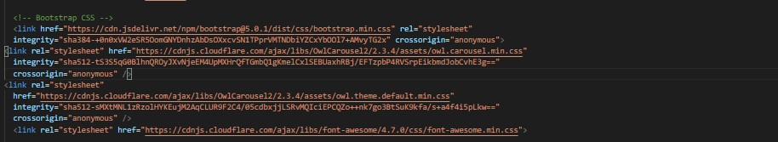

### Description:

I have used bootstrap in this website. Which was a ready- made CSS file, so we can use it to reduce our time and also it carries a (N) number of designs. So, I had linked them to the code in HTML.

**Chapter7:**

### Project README (Description, steps to run, future, improvement)

* **Project-1- Simulation of ball-movement**

### Screenshot (51)

### * Project-2- Random walk Movement

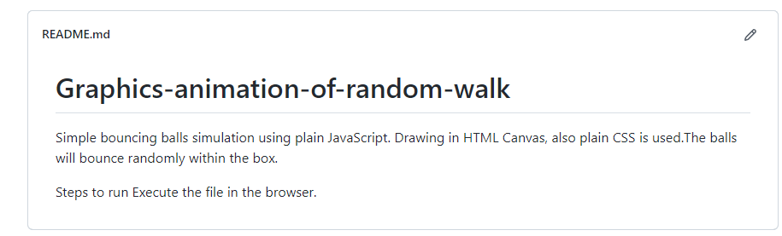

* **Project-3- pacman-Assignment**

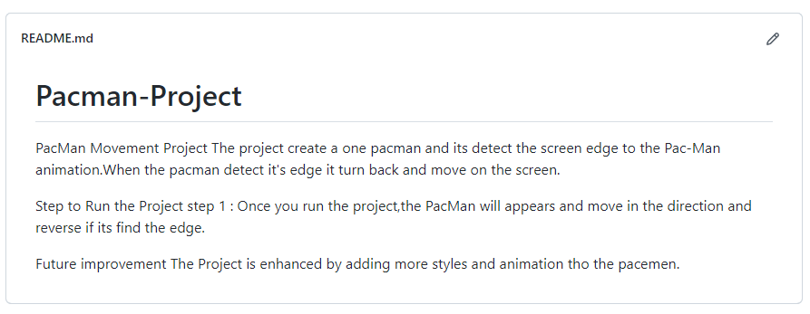

### * Project-4- Walk boston

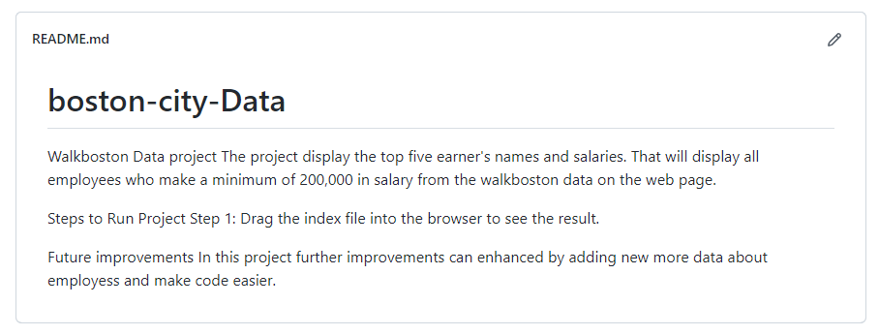

* **Project-5- Word count**

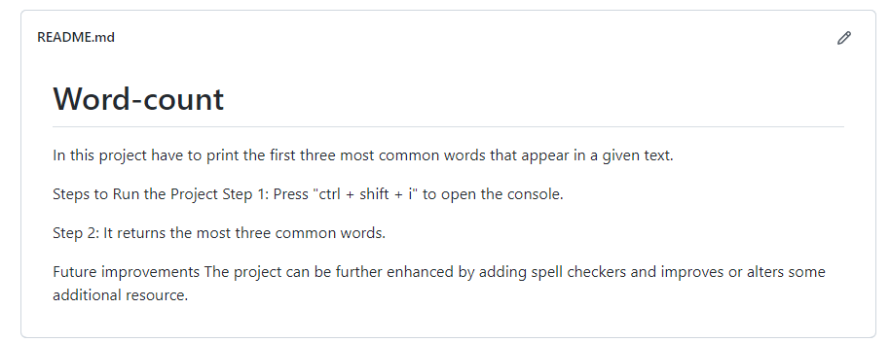

# Chapter8:

### File structure

### **8.1 Github file structure**

Task- 1 file structure:

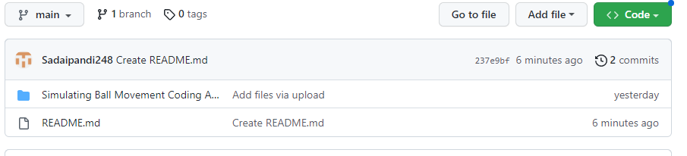

Task- 2 file structure:

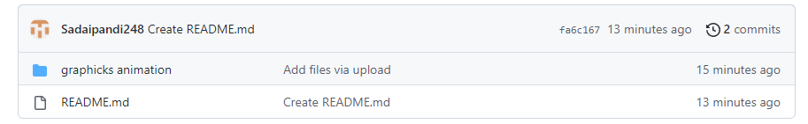

Task- 3 file structure:

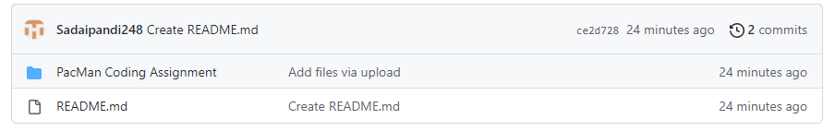

Task- 4 file structure:

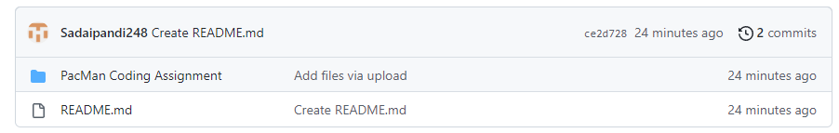

Task- 5 file structure:

